**EECS 331: Introduction to Computational Photography**

HW3: High Dynamic Imaging and Tone-mapping

1. **Write an Auto Exposure Bracketing (AEB) function for Tegra**

Android program ‘backbone’ was modified to fulfil the given conditions.

Minimum Exposure of Tegra: 33600 ns

Maximum Exposure of Tegra: 358732928 ns

Multiple images of a scene are captured and the exposure times recorded.

The following are a few images of the scenes:

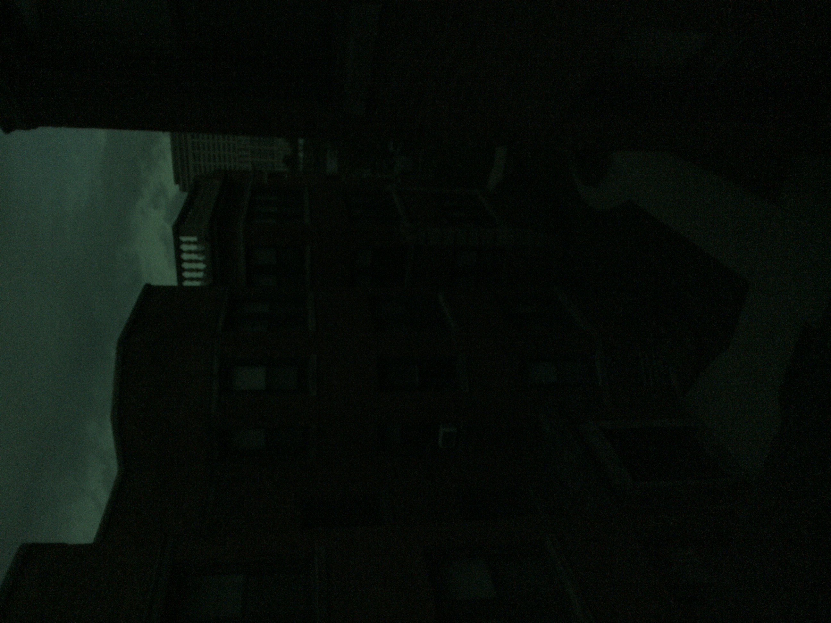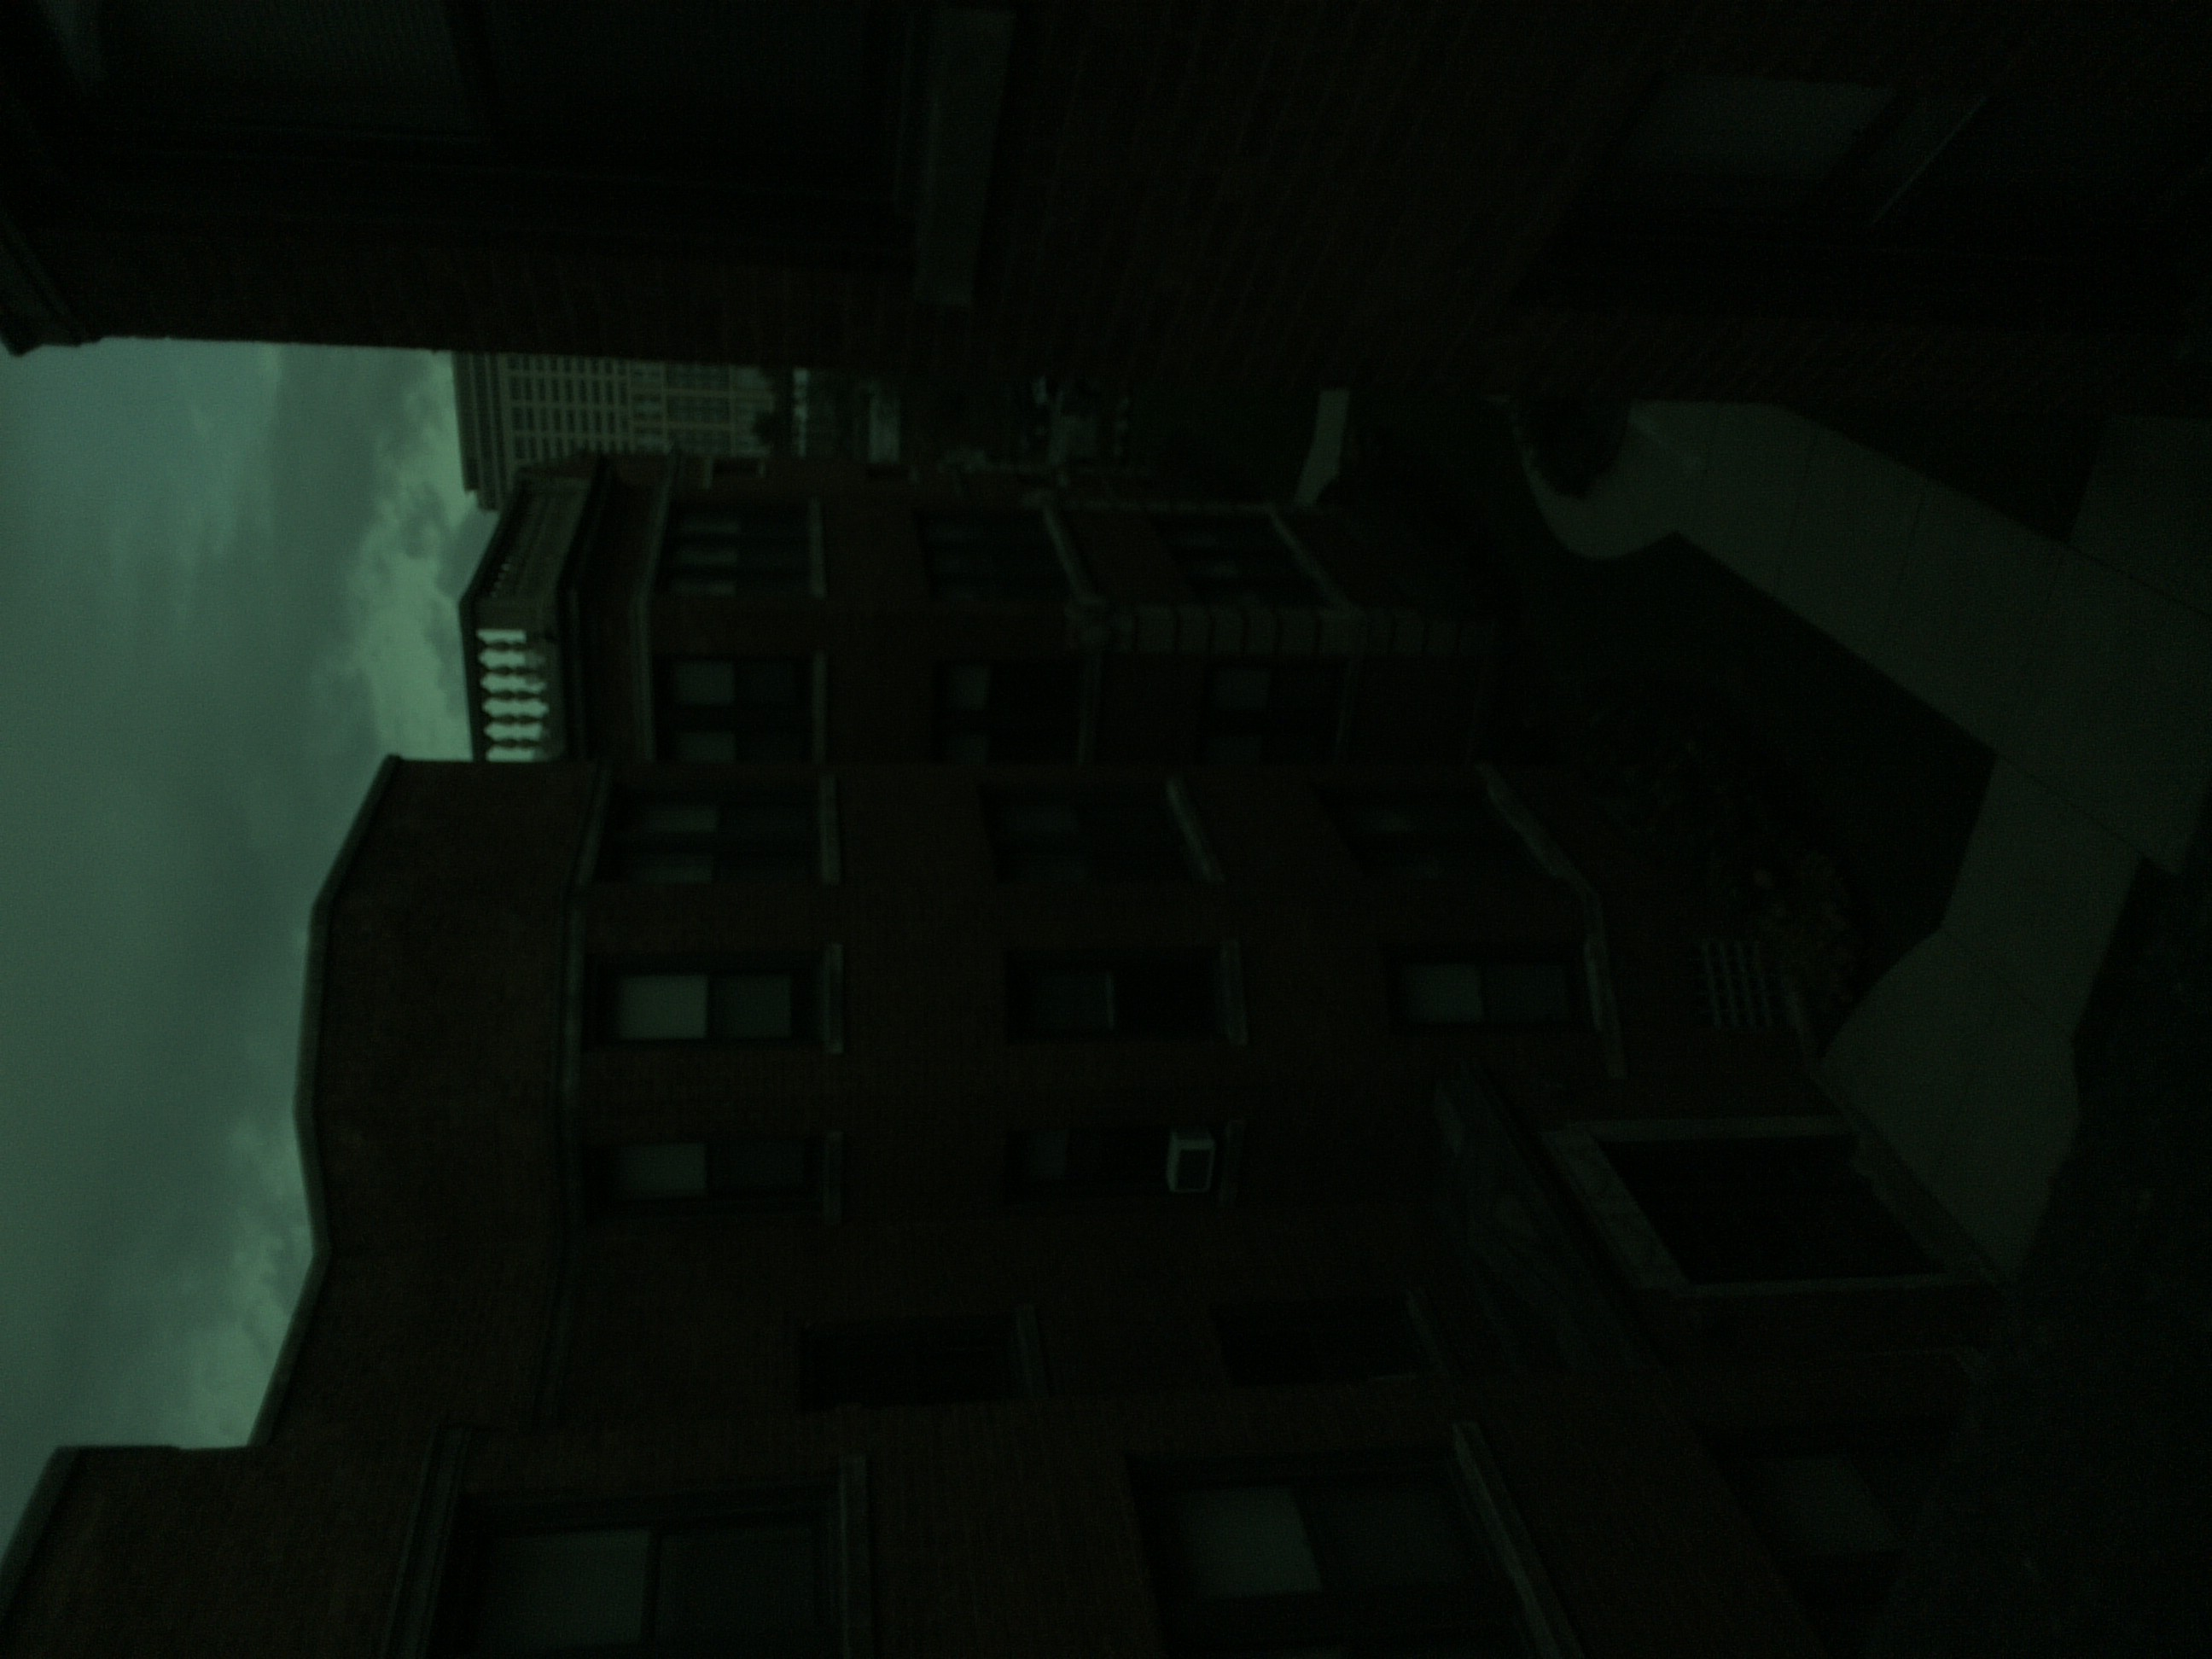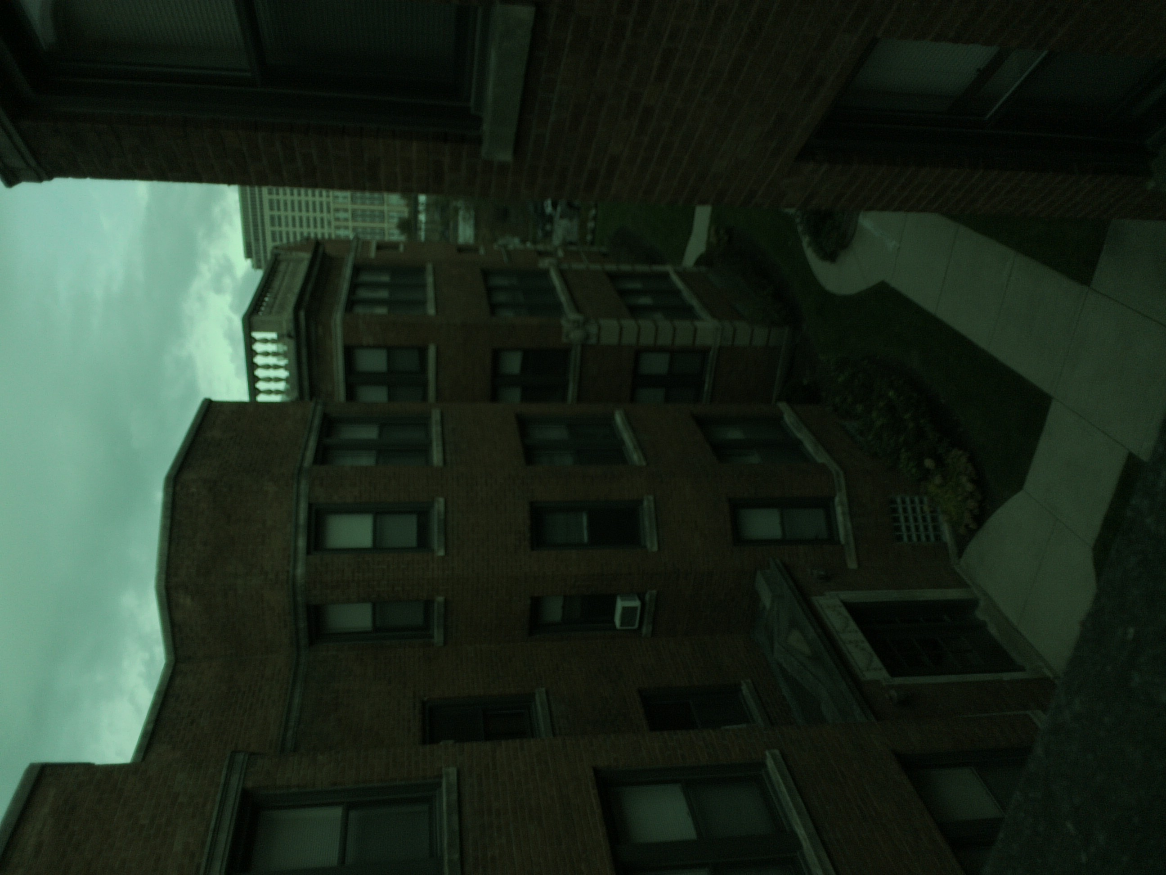

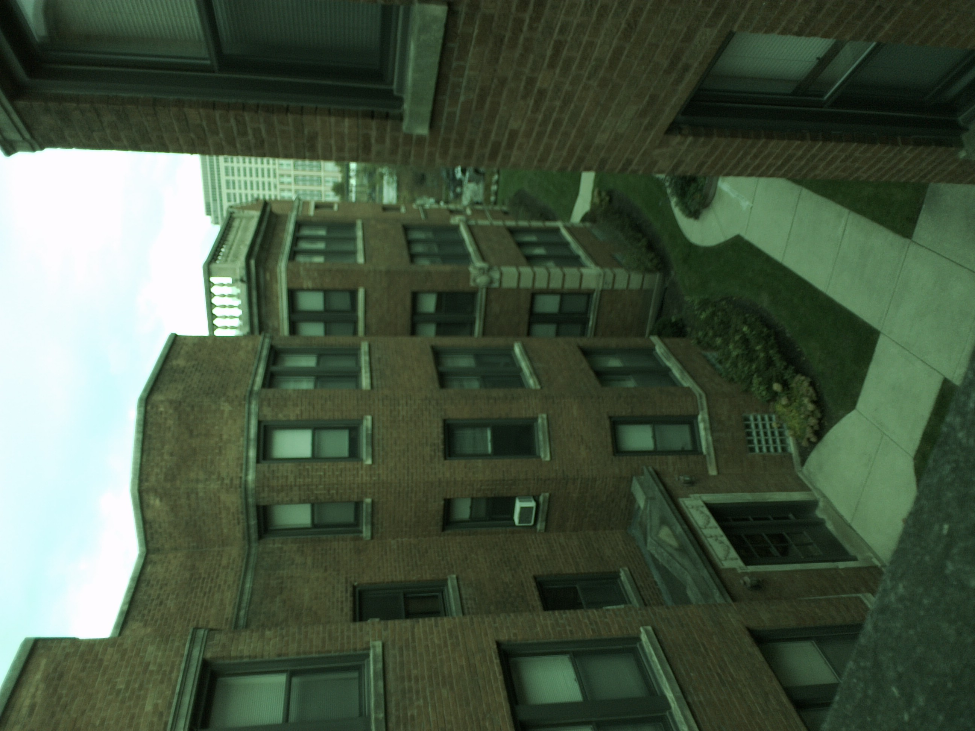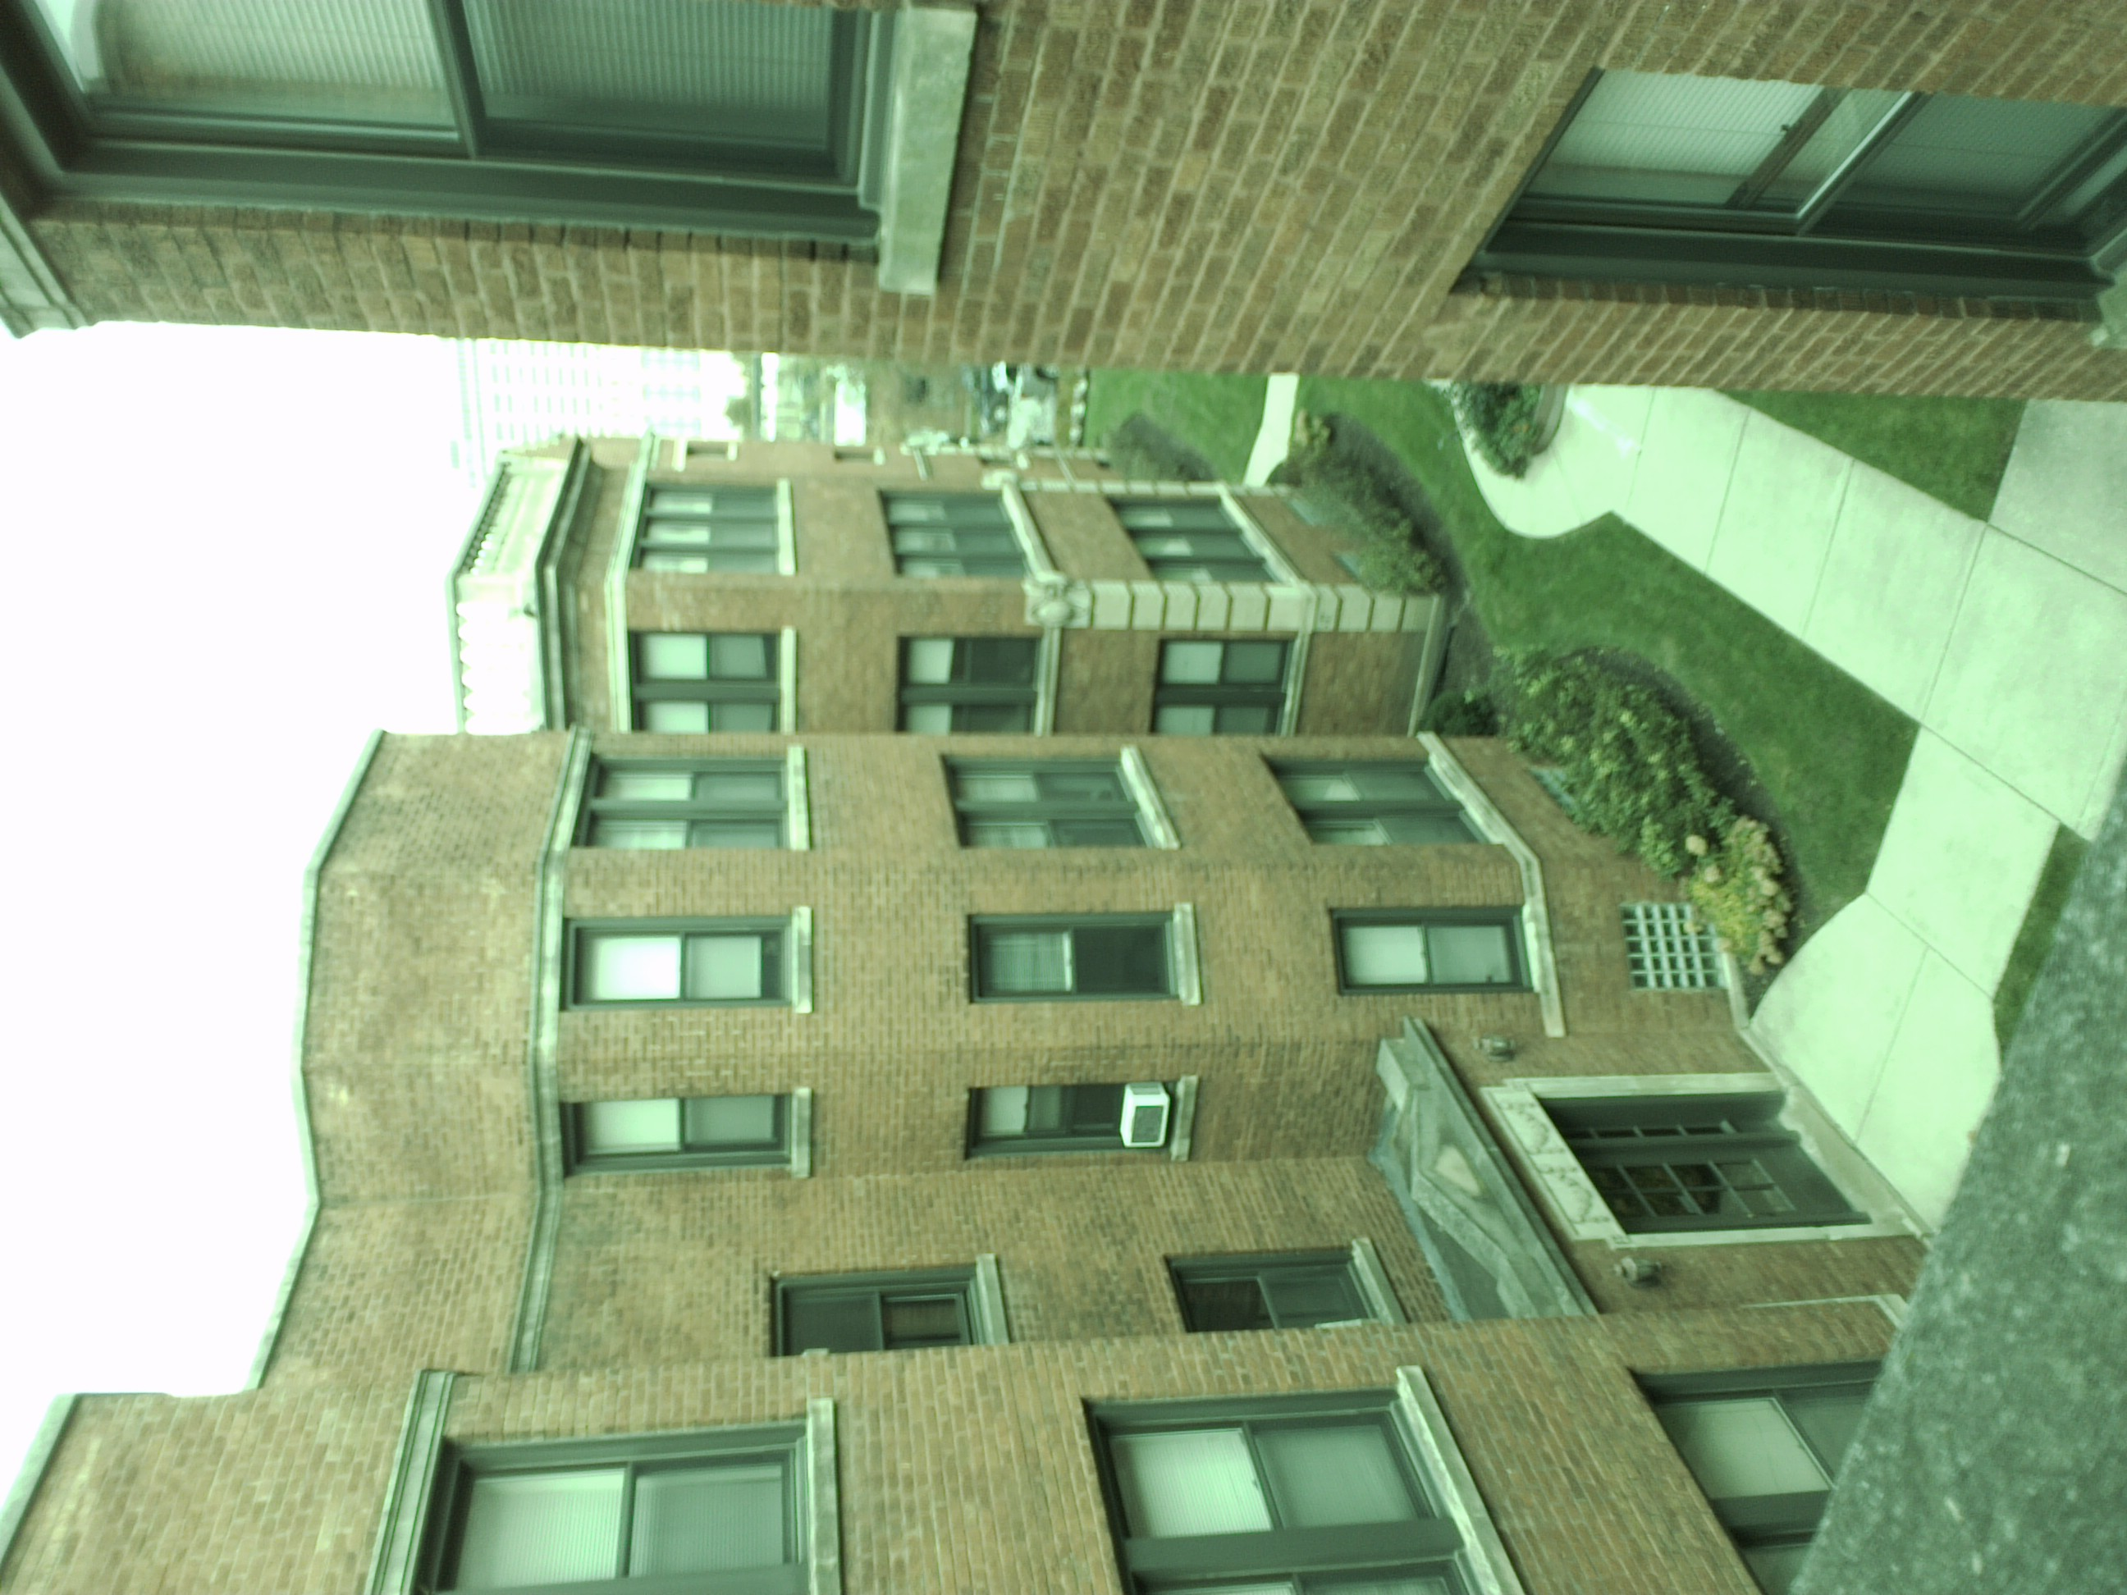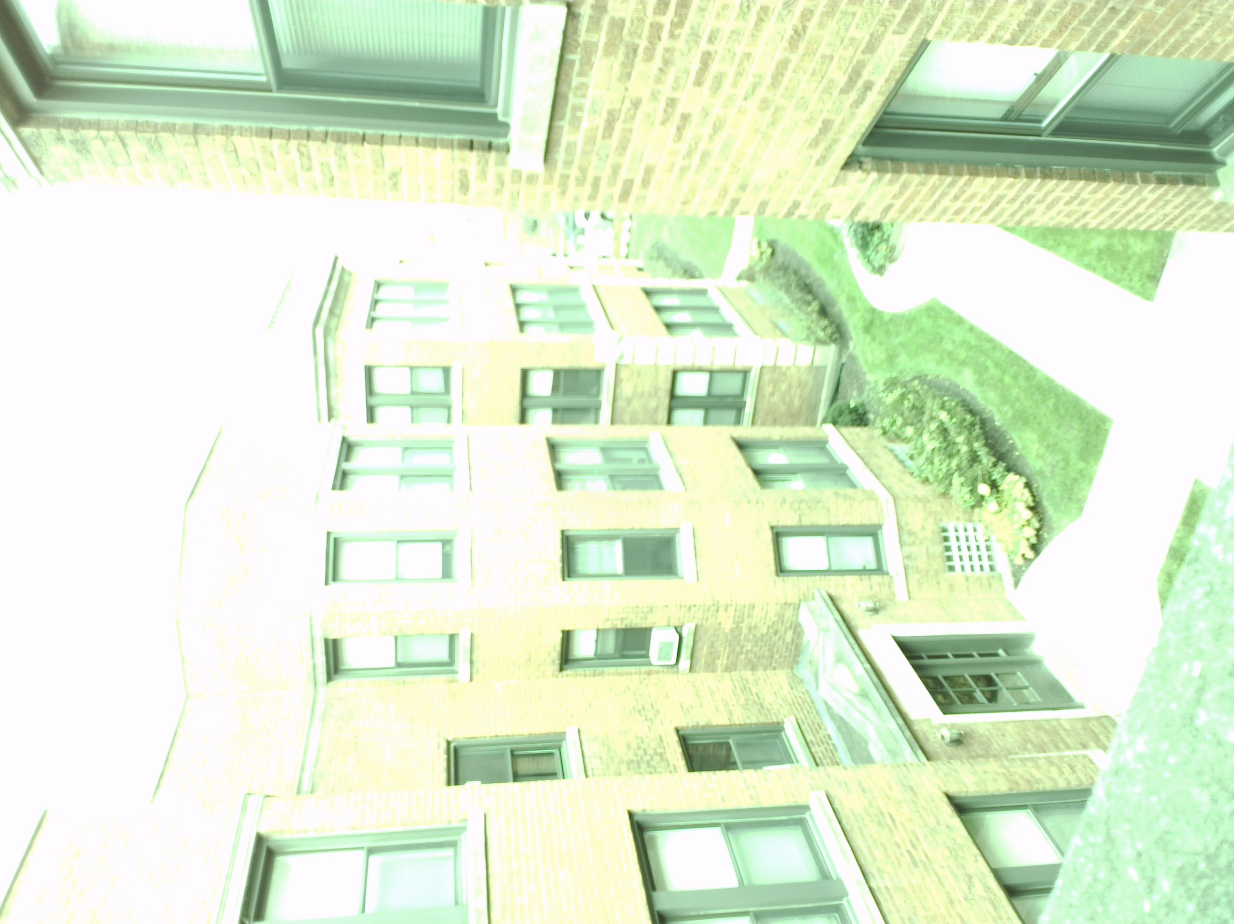

Fig 0: Samples of chosen scene

1. **Write a program to find the camera response curves for the shield tablet**

Regularization Parameter *‘l’* = 5

For lower values of *‘l’* it can be seen that there is higher deviation in the scatter plot.

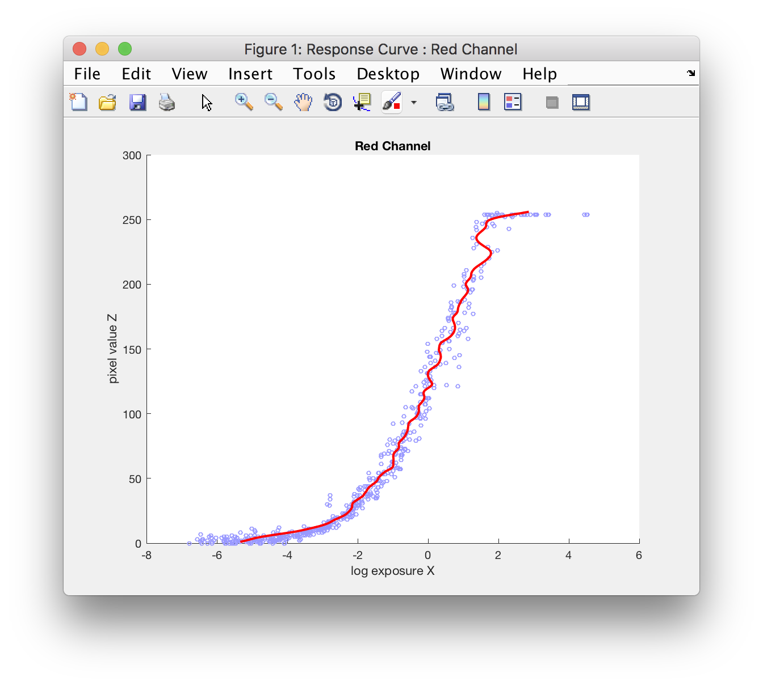

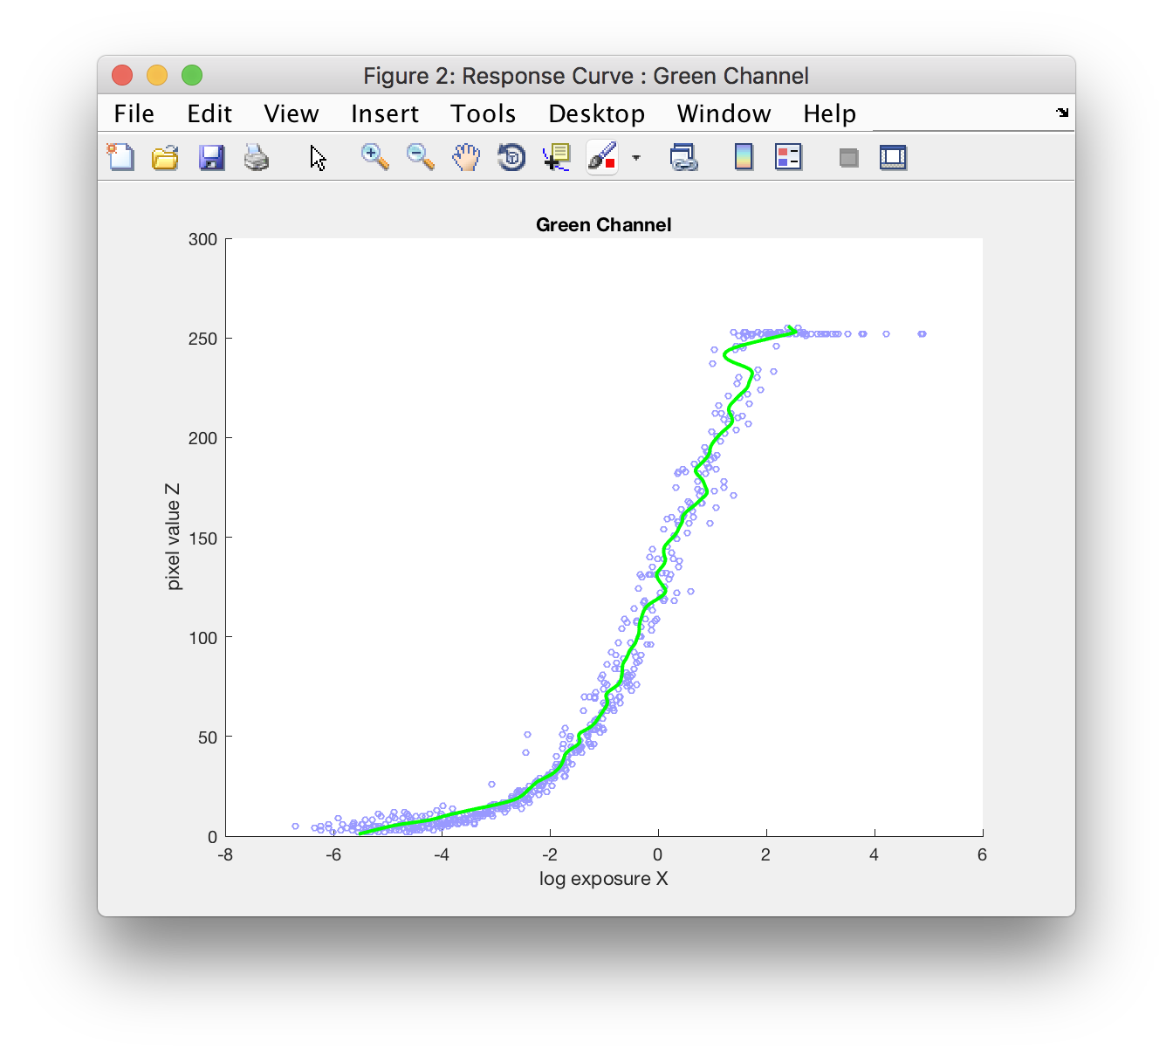

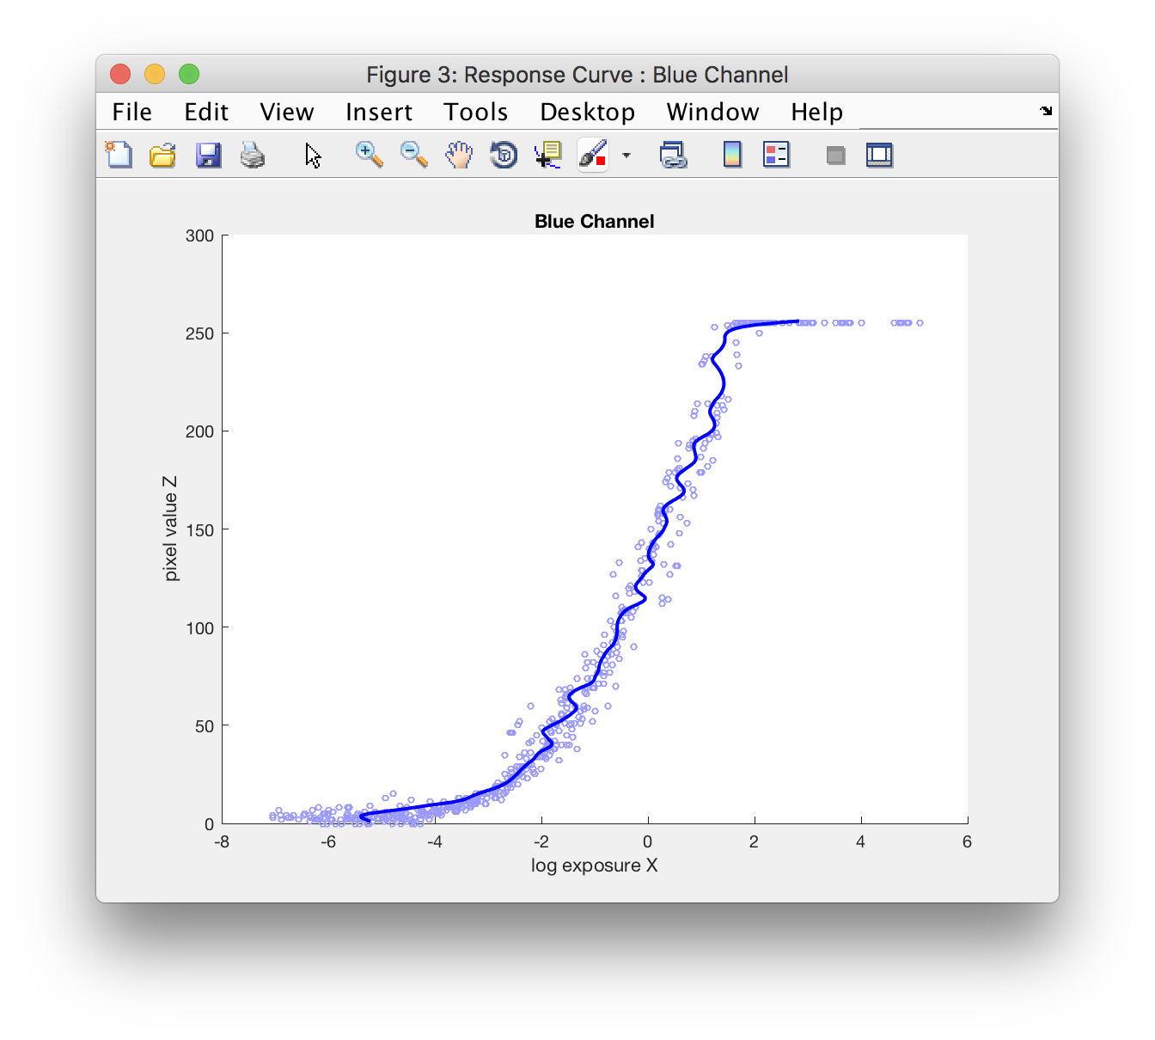

1. **Recover the HDR radiance map of the scene**

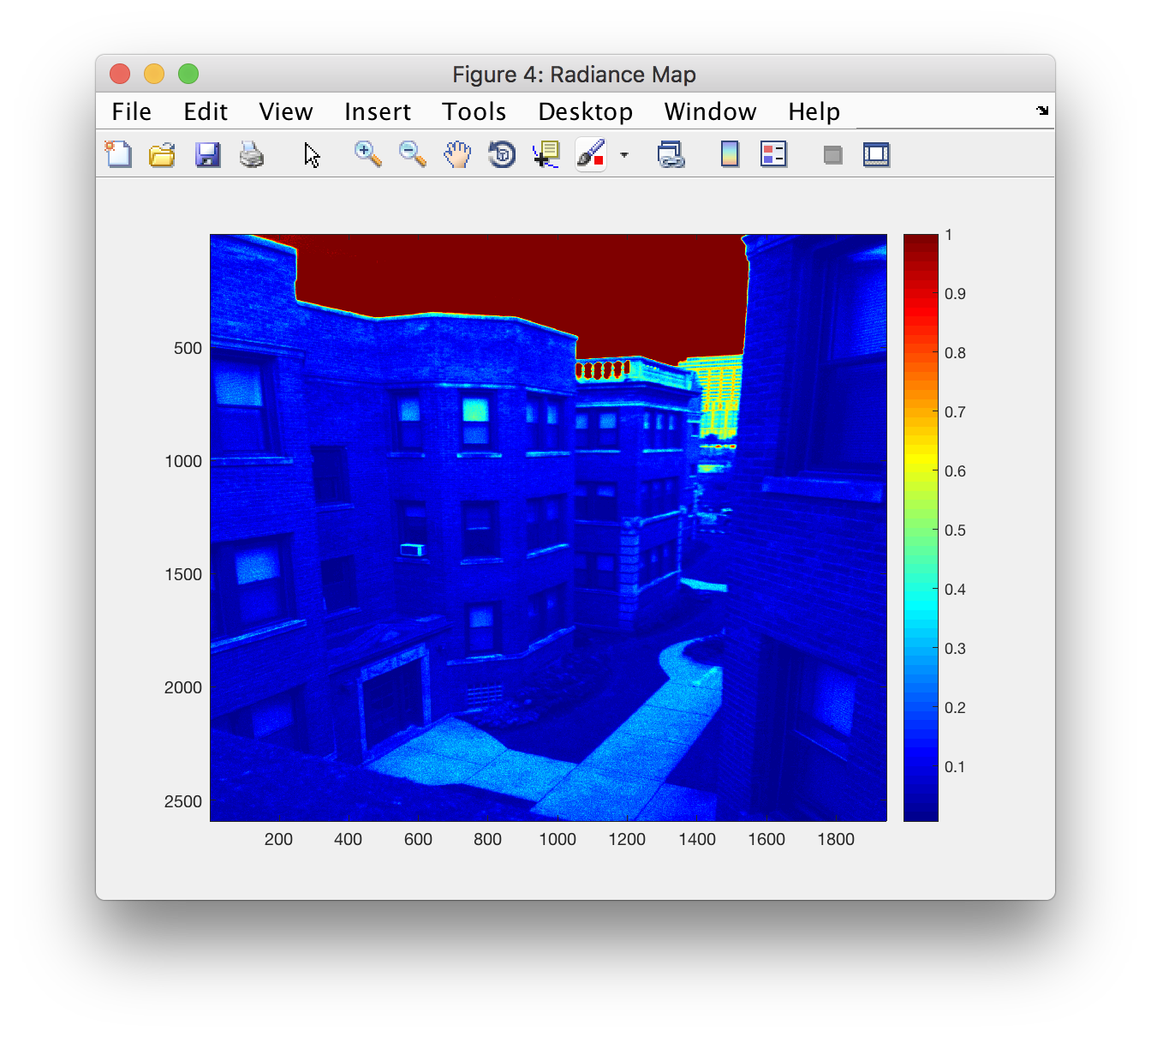

1. **What is the dynamic range of your scene?**

The Tegra camera could capture 13 images over its exposure range with 2X changes in the EV.

Therefore, no of stops/EV = 13

The Dynamic Range : 10^5:1 or 10,000:1

1. **Implement a tone mapping algorithm to display your HDR image**
   1. Scaling the brightness of all pixels

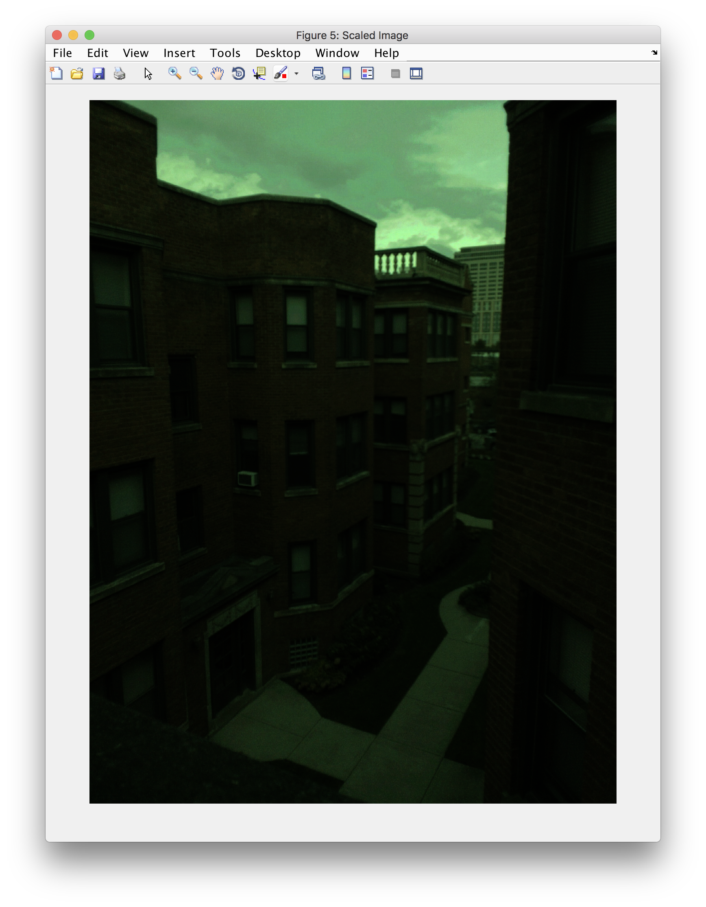

* 1. Applying a gamma curve

Gamma value chosen ‘γ’ = 0.3

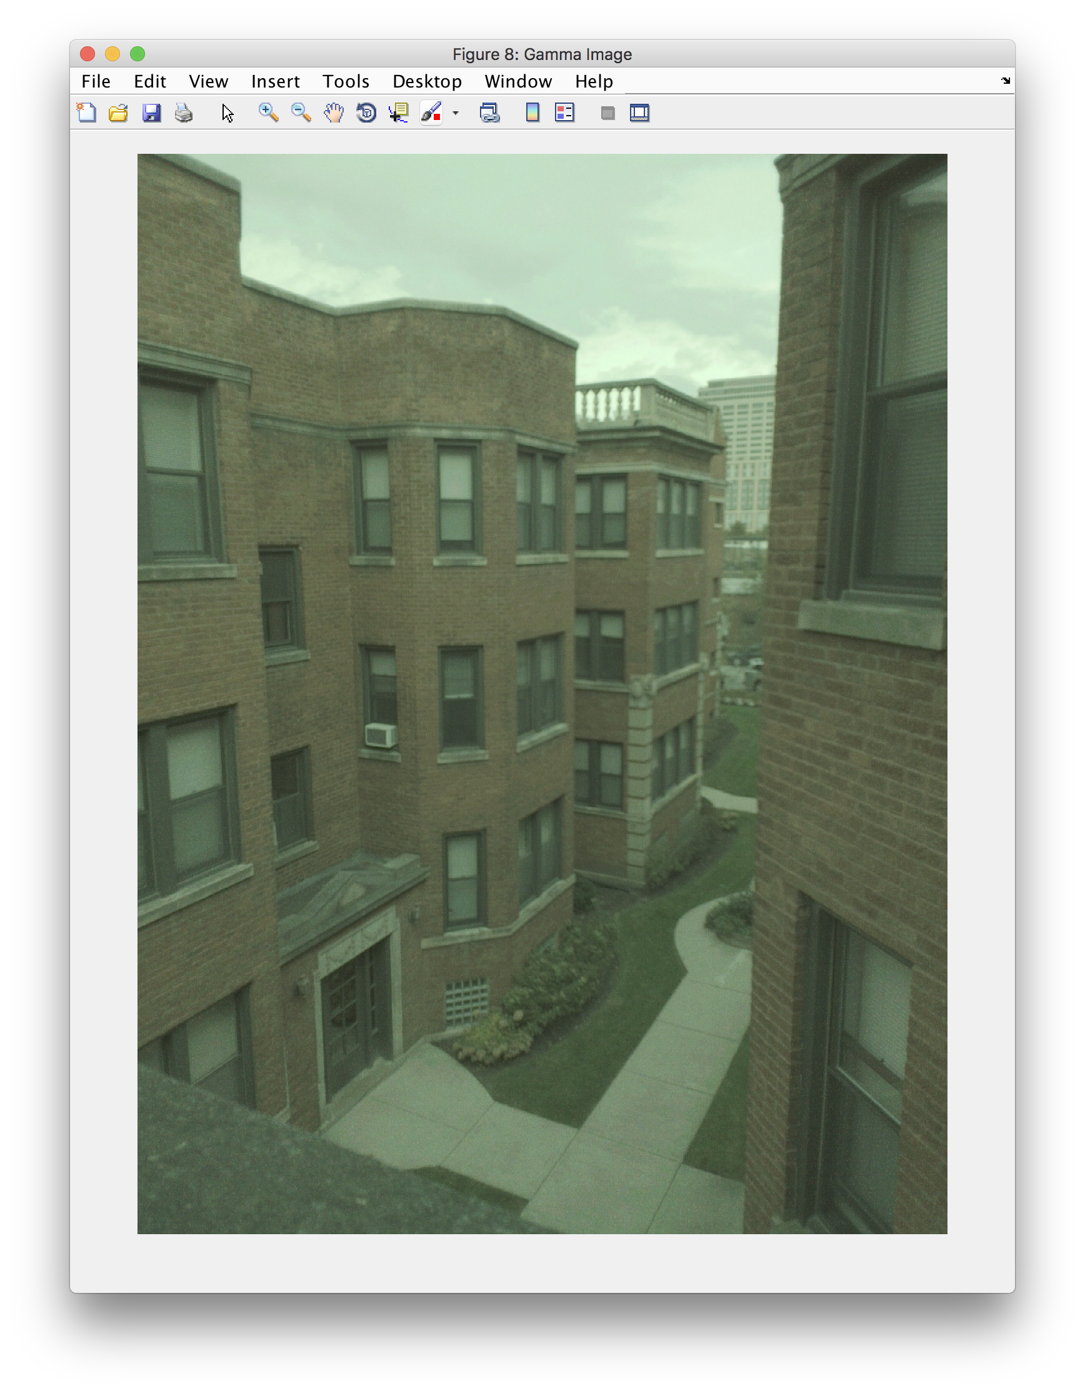

* 1. Applying Global Tone Mapping from Reinhard ’02.

‘a’ value chosen = 0.6

